After running open the tests/_output/index. html file in your browser, you will see an explicit coverage report for each directory and class:

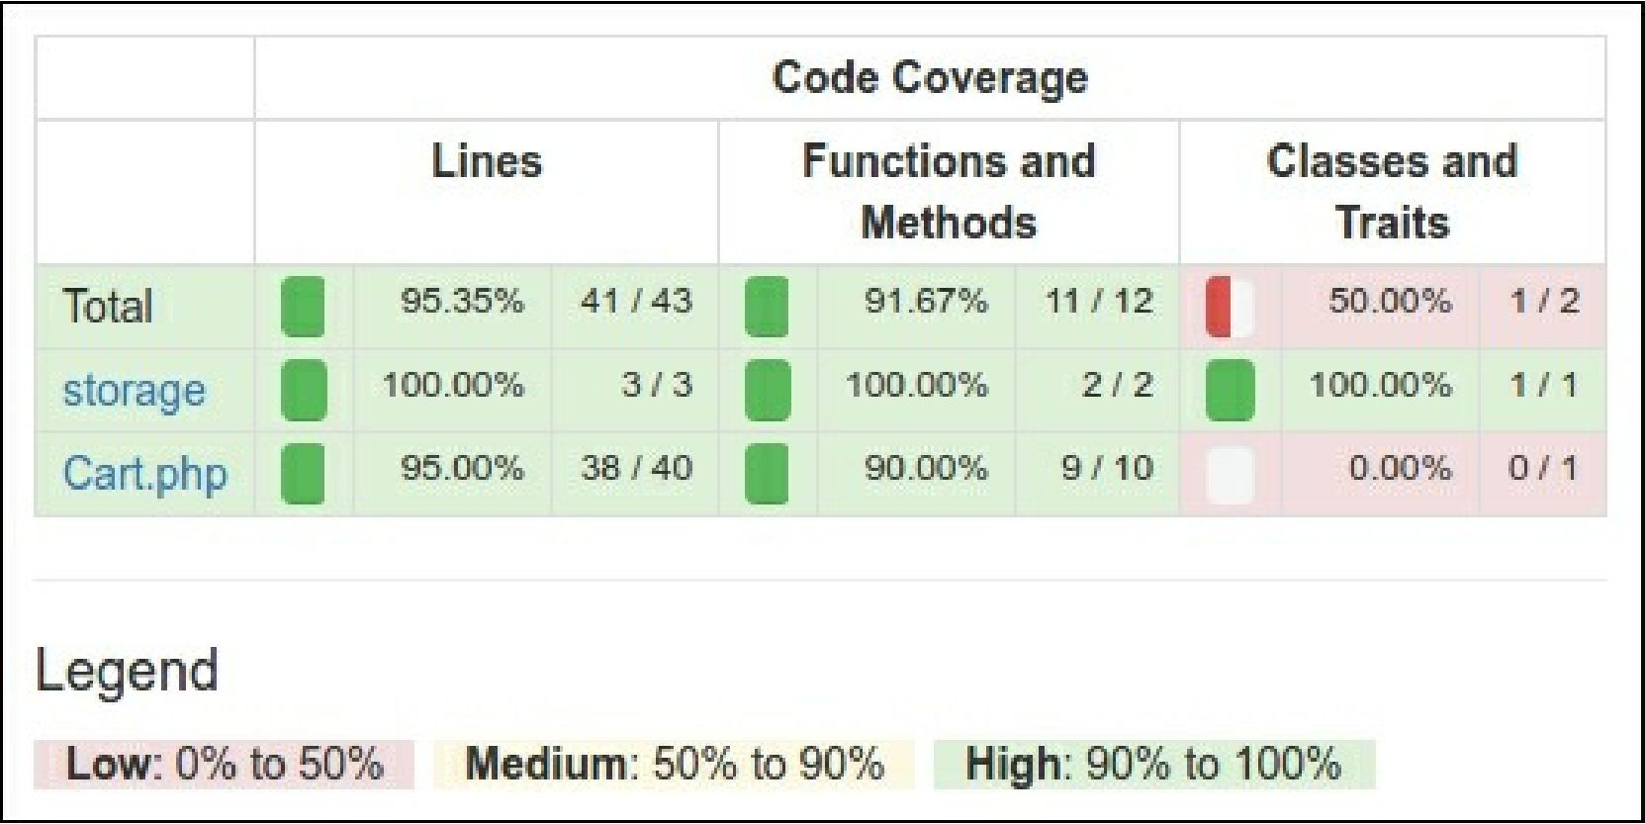

You can click on any class and analyze which lines of code have not been executed during the testing process. For example, open our Cart class report:

|  |  |  |
| --- | --- | --- |
| **20** | **public** | **function setStorage{$storage)** |
| **21** |  |  |
| **22** | **if** | **{is array($storage)) {** |
| **23** |  | **$this-> storage = \Yii::createQbject($storage);** |
| **24** | **}** | **else {** |
| **25** |  | **$this->_storage = Sstorage;** |
| **26** | **}** |  |
| **27** | **>** |  |

In our case, we forgot to test the creating storage from array configuration.

**Usage of component**

After publishing the extension on Packagist, we can install a one-to-any project: composer require book/cart